Document History
Document Name | Detail | Status | Date | View able | Reviewer& Responsible
HanDIYcraft-Project Plan-0.1.docx | -Introduction  -Schedule and Milestones | Draft | 10/4/14 | Advisor | NK, PS
HanDIYcraft -Project Plan-0.2.docx | -Update Introduction  - Infrastructure  - Quality Planning  - Estimated Effort and Costs  -Version Control Strategy | Draft | 8/4/14 | Advisor | NK, PS
HanDIYcraft -Project Plan-0.3.docx | -Update Infrastructure  - Management Procedures  - Estimate Duration of Tasks | Draft | 27/4/14 | Advisor | NK, PS
HanDIYcraft -Project Plan-0.4.docx | -Deliverables and Limit  -Future Work | Draft | 28/4/14 | Advisor | NK, PS
HanDIYcraft -Project Plan-0.5.docx | - Motivation  - Aim and Object  - Architecture Review  - Schedule and Milestone | Draft | 3/4/14 | Advisor | NK, PS
HanDIYcraft -Project Plan-0.6.docx | -Update Aims and Object  - Abstract  - References | Draft | 4/4/14 | Advisor | NK, PS

NK : Nahathai Kaewtatib
PS : Pimchanok Sripraphan

…………………………
Ms. Nahathai Kaewtatib
Project Proposal Writer

…………………………
Ms. Pimchanok Sripraphan
Project Proposal Writer

26th March 2014

Table of Contents
Chapter One| Introduction 5
1.1 Project Overview 7
1.1.1 Purpose 18
1.1.2 Scope 18
1.1.3 Acronyms and Definitions 18
1.2 Work Product to be developed 9
1.2.1 Deliverables 18
1.2.2 Non-Deliverables 18
Chapter Two | Infrastructure 7
2.1 Hardware/Software Acquisition 7
2.1.1 Hardware 18
2.1.2 Software Acquisition 18
2.2 Project Specific System Administration Support Needed 7
2.2.1 Software needed 18
Chapter Three | Management Procedures 18
3.1 Project team structure 18
3.2 Monitoring and Controlling Mechanisms 18
3.2.1 Software Development Model 18
3.2.2 Status Reporting 18
3.2.3 Project Meeting 18
3.3 Change Management 18
Chapter Four | Quality Planning 20
4.1 Quality Factors 20
4.1.1 Product Operation Factors 21
4.1.2 Product Revision Factors 21
4.1.3 Product Transition Factors 21
4.2 Reviews and Responsibility 21
4.3 Testing 22
4.4 Software Development Standard 23
4.4.1 ISO92110 for Very Small Entity (VSE) 21
4.4.2 Project Management (PM) process 21
4.4.3 Software Implementation (SI) process 21
Chapter Five | Estimated Duration of Tasks 30
Chapter Six | Estimated Effect and Costs 30
Chapter Seven | Identification of Project Risks 30

Chapter Eight | Version Control Strategy 30
8.1 Naming Conversion 20
8.2 Project Repository 20
8.3 Configuration Item Table 20
Chapter Nine | Schedule and Milestones 30
Chapter Ten | Appendix 30

Chapter One | Introduction

Our project is the project from SE499 (Senior Project), which consists of two members. The project is about DIY tutorials that will be provided as both mobile and web application. This project plan document presents the way we will manage a software project through times. Also, explains the detail of each process from the initialing to the closing one.
1.2 Project Overview
HanDIYcraft is a web application and mobile application for smartphone that supports Android operating system. It is an application that guide users the method how to turn their old things, into a new one by themselves. This application provides several tutorials for users to learn. Moreover, in case the users do not have the needed materials and have no idea where to buy, this application provides a feature to let the users check out the shops that sell related materials for making their DIY artworks. Apart from just exploring, the users can also directly communicate with the shopkeepers by sending private messages.
    - Purpose
- Open up DIY ideas for the users and bloggers.
- Let shopkeepers advertise their shops.
- Help bloggers find the places where they could get the materials they want by Map feature.
- Let bloggers communicate among themselves and with the shopkeepers.

    - Scope
Main features of HanDIYcraft are listed as follows:
Feature 1: Authorization Management
- Develop register, log in, and log out system for bloggers. (On both web and mobile)
- Develop register, log in, and log out system for shopkeepers. (On mobile)
- The system can display user’s (blogger/shopkeeper) profile and let the users edit their information.

Feature 2: Tutorial Management (On both web and mobile)
- Bloggers can manage tutorials.
- Bloggers can add detail of the tutorial step by step.
- Bloggers can pictures for the tutorial.
- Bloggers can add a video for the tutorial.
- Bloggers and users can search tutorials by keyword.
- The system can display tutorials that exist in the database.

Feature 3: Shop Management (On mobile)
- Shopkeepers can manage shops.
- Shopkeepers can add information of the shop.
- Shopkeepers can add pictures of the shop.

Feature 4: Map Management
- Develop Map using Google Maps API. (On both web and mobile)
- Bloggers can see the location of shops. (On both web and mobile)
- Shopkeepers can pin the location of the shop. (On mobile)

Feature 5: Communication Management
- Bloggers can communicate to each other via comment. (On both web and mobile)
- Bloggers and shopkeepers can communicate to each other via private message. (On both web and mobile)
- Shopkeepers can search bloggers using their username. (On mobile)
- Bloggers can give likes on tutorials. (On both web and mobile)
- Bloggers can follow other bloggers. (On both web and mobile)
- Bloggers can share a tutorial on Facebook. (On both web and mobile)

Feature 6: The system provides notifications. (On both web and mobile.

1.2.3 Acronyms and Definitions
- Acronyms
PMP = Project Management Plan
SDD = Software Design Document
SRS = Software Requirement Specification
SW = Siraprapa Wattanakul
NK = Nahathai Kaewtatib
PS = Pimchanok Sripraphan

  - Work Product to be developed

    - Deliverables
No. | Deliverables/Release | Media | No. of Copies | Date
1 | Project Proposal  - HanDIYcraft Proposal version 1.0 | Hard Copy | 4 | 26/3/2014
1 | - HanDIYcraft Proposal version 2.0 | Hard Copy | 1 | 23/4/2014
2 | The Progress Report I  - Project Management Plan version 1.0  - Software Requirement Specification version 1.0  - Software Design Document version 1.0  - Test Plan version 1.0  - Traceability Record version 1.0 | Hard Copy | 4
3 | The Progress Report II  - Project Management Plan version 2.0  - Software Requirement Specification version 2.0  - Software Design Document version 2.0  - Test Plan version 2.0  - Traceability Record version 2.0 | Hard Copy | 4
4 | The Progress Report III (Show Pro)  - Project Management Plan version 3.0  - Software Requirement Specification version 3.0  - Software Design Document version 3.0  - Test Plan version 3.0  - Traceability Record version 3.0 | Hard Copy | 4
5 | The Final Progress Report  - Project Management Plan version 4.0  - Software Requirement Specification version 4.0  - Software Design Document version 4.0  - Test Plan version 4.0  - Traceability Record version 4.0 | Hard Copy | 4
6 | - Software Source code version 1.0 | Software | 4

    - Non-Deliverables

No. | Work Products | Media
1 | 30 seconds video presentation | File
2 | 5 minutes video presentation | File
3 | Poster presentation | Poster

Chapter Two | Infrastructure

  - Hardware/Software Acquisition Plans
    - Hardware
- Computer
- Smart phone with Android OS version 4.2
    - Software Acquisition Plans
- Server
- Internet

  - Project Specific System Administration Support Needed
    - Software needed
- Eclipse
- Android SDK
- MySQL Server
- Web Server
- Web Browser
- GitHub
- Gantt Chart
- Visual Paradigm for UML
- Photoshop
- Microsoft Word
- Microsoft PowerPoint

Chapter Three |
Management Procedure

  - Project Team Structure
Project Team Members:
- Ms. Nahathai Kaewtatib 542115018
- Ms. Pimchanok Sripraphan 542115043
Responsibility | Owner | Reviewer
Project Proposal | PS | NK
Project Plan and Quality Plan | PS | NK
Requirement Specification | PS | NK
Design Document | PS | NK
Implementation | PS | NK
Traceability Record | PS | NK
Testing Record | PS | NK

  - Monitoring and Controlling Mechanisms
    - Software Development Model
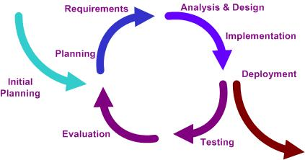

Iterative Model is a popular software development life cycle model that is used in software development process. It starts with a simple implementation of a small set of the software requirements, and iteratively increase it until the whole system is complete and ready to be deployed.
    - Status Reporting
No. | Progress Report | Software Items | Date
1 | Project Proposal Report | - Proposal | 26/4/2014
2 | 1st Progress Report | - Project Management Plan  - Software Requirement Specification  - Software Design Document  - Implemented Software Progress I  - Test Plan  - Traceability Record
3 | 2nd Progress Report | - Project Management Plan  - Software Requirement Specification  - Software Design Document  - Implemented Software Progress II  - Test Plan  - Traceability Record
4 | 3rd Progress Report (Show Pro) | - Project Management Plan  - Software Requirement Specification  - Software Design Document  - Implemented Software Progress III  - Test Plan  - Traceability Record
5 | Final Progress Report | - Project Management Plan  - Software Requirement Specification  - Software Design Document  - Complete Software Source code  - Test Plan  - Traceability Record
No. | Participants | Roles
1 | Ms. Siraprapa Wattanakul | Project advisor
2 | Ms. Nahathai Kaewtatib | Development team member
3 | Ms. Pimchanok Sripraphan | Development team member

    - Project Meeting

  - Change Management
Change Management manages and controls all of the changes that happen during the project development process. The change requests will be recorded into the change management document.

Here are the steps of our strategy for change management:
- Analyze the change request (How necessary it is and the impact to the other part of the system).
- Set a change request form.
- Approve the change request by the project advisor.
4. Change the project according to the approved change request.

Chapter Four | Quality Planning

  - Quality Factors
HanDIYcraft software should meet these quality factors according to the McCall’s Model.

    - Product Operation Factors
Correctness
The software should provide more than 80% of data as the user requested correctly.
Usability
The software should provide understandable and easy-to-use GUI and language.
Reliability
The software should perform with more than 80% of usual activities, and with less than 10% of failure.
Integrity
The software should be able to identify between authorized and unauthorized users, and also between each type of users.

    - Product Revision Factors
Maintainability
*The software should perform with more than 80% of usual activities, and with less than 10% of failure.
Testability
The software should be 100% tested.

    - Product Transition Factors
Reusability
More than 50% of the complete software should be able to be reused in the future.

  - Reviews and Responsibility

Stage Exit Review
No. | Stage | Software Items | Owner | Reviewer
1 | 1st Progress | Project Management Plan | PS | NK
2 | 1st Progress | Software Requirement Specification | PS | NK
3 | 1st Progress | Software Design Document | PS | NK
4 | 1st Progress | Test Plan | PS | NK
5 | 1st Progress | Traceability Record | PS | NK
6 | 2nd Progress | Project Management Plan | PS | NK
7 | 2nd Progress | Software Requirement Specification | PS | NK
8 | 2nd Progress | Software Design Document | PS | NK
9 | 2nd Progress | Test Plan | PS | NK
10 | 2nd Progress | Traceability Record | PS | NK
11 | 3rd Progress | Project Management Plan | PS | NK
12 | 3rd Progress | Software Requirement Specification | PS | NK
13 | 3rd Progress | Software Design Document | PS | NK
14 | 3rd Progress | Test Plan | PS | NK
15 | 3rd Progress | Traceability Record | PS | NK
Test Process
No. | Test | Responsibility
1 | Unit Test | NK, PS
2 | System Test | NK, PS
3 | Acceptance Test | NK, PS

  - Testing

  - Software Development Standard

4.4.1 ISO29110 for Very Small Entity (VSE)
ISO29110 is a guide applies to a Very Small Entity (VSE), enterprise, organization, department or project up to 25 people, dedicated to software development. The Guide provides Project Management and Software Implementation processes which integrate practices based on the selection of ISO/IEC 12207- Systems and Software Engineering — Software Life Cycle Processes and ISO/IEC 15289Software Engineering – Software Life Cycle Process – guidelines for the content of software life cycle process information products (documentation) standards elements.
4.4.2 Project Management (PM) process
PM Purpose
The purpose of the Project Management process is to establish and carry out in a systematic way the tasks of the software implementation project, which allows complying with the project’s objectives in the expected quality, time and costs.
PM objectives
PM.O1. The Project Plan for the execution of the project is developed according to the Statement of Work and validated with the Customer. The tasks and resources necessary to complete the work are sized and estimated.
PM.O2. Progress of the project is monitored against the Project Plan and recorded in the Progress Status Record. Corrections to remediate problems and deviations from the plan are taken when project targets are not achieved. . Appropriate treatment is taken to correct or avoid the impact of risk. Closure of the project is performed to get the Customer acceptance documented in the Acceptance Record.
PM.O3. The Change Requests are addressed through their reception and analysis. Changes to software requirements are evaluated for cost, schedule and technical impact.
PM.O4. Review meetings with the Work Team and the Customer are held. Agreements are registered and tracked.
PM.O5. Risks are identified as they develop and during the conduct of the project.
PM.O6. A software Version Control Strategy is developed. Items of Software Configuration are identified, defined and baselined. Modifications and releases of the items are controlled and made available to the Customer and Work Team including the storage, handling and delivery of the items.
PM.O7. Software Quality Assurance is performed to provide assurance that work products and processes comply with the Project Plan and Requirements Specification.
PM Activities
The Project Management Process has the following activities:
- - PM.1 Project Planning
- - PM.2 Project Plan Execution
- - PM.3 Project Assessment and Control
- - PM.4 Project Closure
4.4.3 Software Implementation (SI) process
SI purpose
The purpose of the Software Implementation process is the systematic performance of the analysis, design, construction, integration and tests activities for new or modified software products according to the specified requirements.
SI objectives
SI.O1. Tasks of the activities are performed through the accomplishment of the current Project Plan.
SI.O2. Software requirements are defined, analyzed for correctness and testability, approved by the Customer, baselined and communicated.
SI.O3. Software architectural and detailed design is developed and baselined. It describes the software items and internal and external interfaces of them. Consistency and traceability to software requirements are established.
SI.O4. Software components defined by the design are produced. Unit test are defined and performed to verify the consistency with requirements and the design. Traceability to the requirements and design are established.
SI.O5. Software is produced performing integration of software components and verified using Test Cases and Test Procedures. Results are recorded at the Test Report. Defects are corrected and consistency and traceability to Software Design are established.
SI.O6. A Software Configuration, that meets the Requirements Specification as agreed to with the Customer, which includes user, operation and maintenance documentations is integrated, baselined and stored at the Project Repository. Needs for changes to the Software Configuration are detected and related Change Requests are initiated.
SI.O7. Verification and Validation tasks of all required work products are performed using the defined criteria to achieve consistency among output and input products in each activity. Defects are identified, and corrected; records are stored in the Verification/Validation Results.
SI activities
The Software Implementation Process has the following activities:
- - SI.1 Software Implementation Initiation
- - SI.2 Software Requirements Analysis
- - SI.3 Software Architectural and Detailed Design
- - SI.4 Software Construction
- - SI.5 Software Integration and Tests
- - SI.6 Product Delivery

Chapter Five |
Estimated Duration of Tasks

Feature 1: Authorization Management
Feature 2: Tutorial Management
Feature 3: Shop Management
Feature 4: Map Management
Feature 5: Communication Management
Feature 6: The system provides notifications.

Task Name | Duration  (in days) | Begin Date | End Date
Project Management Plan
Software Requirement Specification
Software Design
- Use Case Diagram
- Activity Diagram
- Class Diagram
- Sequence Diagram
- ER Diagram
- UI Design
1st Progress Implementation
1st Progress Testing Document
- Test Plan
- Test Record
1st Progress Traceability Record
1st Progress Submission
1st Progress Presentation
Progress I

Progress II

Task Name | Duration  (in days) | Begin Date | End Date
Project Management Plan
Software Requirement Specification
Software Design
- Use Case Diagram
- Activity Diagram
- Class Diagram
- Sequence Diagram
- ER Diagram
- UI Design
2nd Progress Implementation
2nd Progress Testing Document
- Test Plan
- Test Record
2nd Progress Traceability Record
2nd Progress Submission
2nd Progress Presentation

Task Name | Duration  (in days) | Begin Date | End Date
Project Management Plan
Software Requirement Specification
Software Design
- Use Case Diagram
- Activity Diagram
- Class Diagram
- Sequence Diagram
- ER Diagram
- UI Design
3rd Progress Implementation
3rd Progress Testing Document
- Test Plan
- Test Record
3rd Progress Traceability Record
3rd Progress Submission
3rd Progress Presentation

Progress III (Show Pro)

Task Name | Duration  (in days) | Begin Date | End Date
Documentation
- Overall Software Specification
- Overall Software Design
- Overall Traceability Record
- Overall Testing
- Binding Document
Software Source code
Release Software
Advertise Software to Media
Final Progress Submission
Final Progress Presentation

Final Progress

Chapter Six |
Estimated Effort and Costs
Item | Approximately Cost (THB)
Text Books | 1,000
Android Device for testing the system | 5,000
Document Printing | 2,000
Poster Presentation | 500

Chapter Seven |
Identification of Project Risks
Risk | Likelihood/Impact | Mitigation
Time Management | High/High | Catch up the Schedule and Milestones
Less skills, knowledge, and experience | High/High | - Search the information from the Internet  - Ask from the experienced developers.
Dealing with changes | High/High | Use the change management strategy
Unfamiliar with the testing process | Medium/Medium | Study more about the testing process
Hardware crash | Medium/High | Always save the documents and source code into the repository (GitHub)

Chapter Eight |
Version Control Strategy

  - Naming Conversion
The file naming format that we are going to use for all project documents is
“[Project Name]-[Document Name]-[Version]”

  - Project Repository
GitHub provides users free spaces to easily store and share their photos, documents, information, and even source code. It is like a social network for the programmers.

Figure 1.6: Project Repository

List of related document and description
- Proposal: contains involved proposal document files
- Project Plan: contains project plan document files
- SRS: contains software requirement specifications document files
- Design: contains design document files
- Test: contains testing document files
- Traceability Record: contains traceability record files
- Presentation: contains presentation files
- Source Code: contains source code of the project
- GUI: contains the pictures that will be used as Graphic User Interface of the system.
- Others: contain pictures, involved and interesting information, etc.

No. | Item | File Name | File Type | Owner | Path | Baseline Version
1 | Project Proposal | HanDIYcraft-Proposal-V.[version] | .docx | NK, PS | /HanDIYcraft/Proposal
2 | Project Management Plan | HanDIYcraft-ProjectPlan-V.[version] | .docx | NK, PS | /HanDIYcraft/Project Plan
3 | Software Requirement Specification | HanDIYcraft-SRS-V.[version] | .docx | NK, PS | /HanDIYcraft/SRS
4 | Software Design Document | HanDIYcraft-SDD-V.[version] | .docx | NK, PS | /HanDIYcraft/Design
5 | Test Plan | HanDIYcraft-TestPlan-V.[version] | .docx | NK, PS | /HanDIYcraft/Test
6 | Test Record | HanDIYcraft-TestRecord-V.[version] | .docx | NK, PS | /HanDIYcraft/Test
7 | Traceability Record | HanDIYcraft-TR-V.[version] | .docx | NK, PS | /HanDIYcraft/Traceability Record
  - Configuration Item Table
Chapter Nine |
Schedule and Milestones

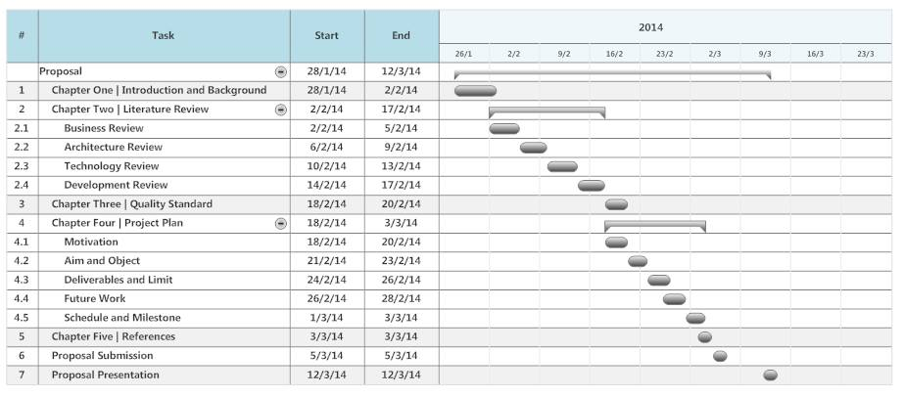

Figure 1.6: The Milestone of Initial Project

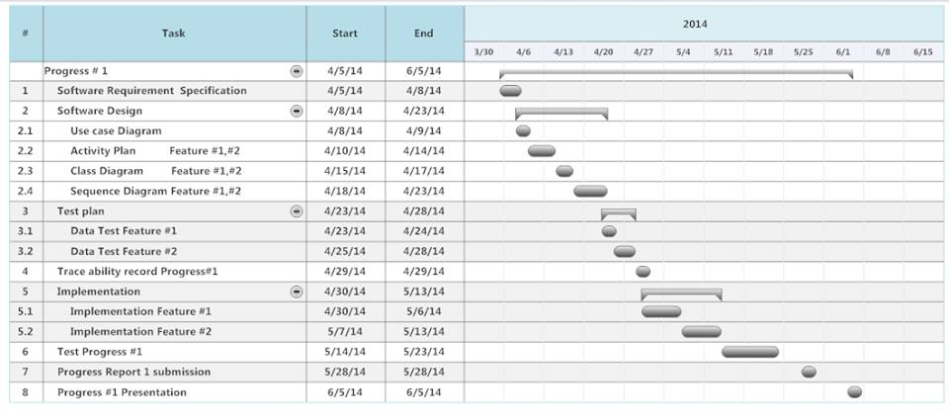

Figure 1.7: The Milestone of First Progress Report

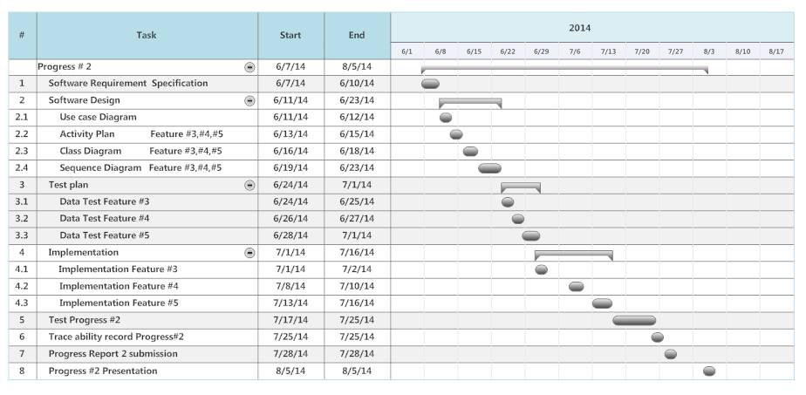

Figure 1.8: The Milestone of Second Progress Report

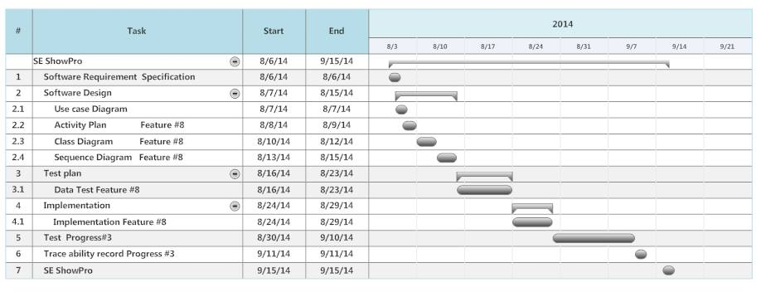

Figure 1.9: The Milestone of Show Pro Progress Report

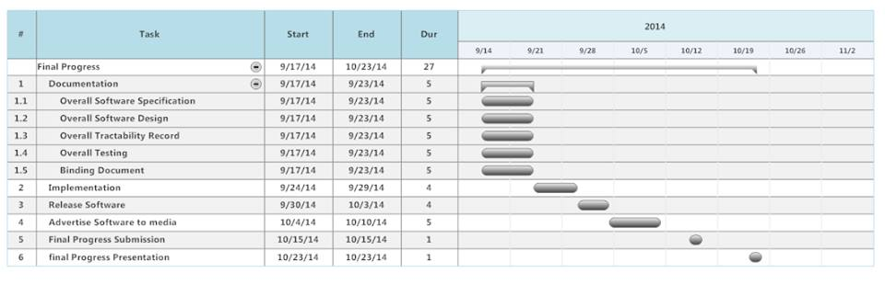

Figure 1.10: The Milestone of Final Progress Report
Chapter Ten | Appendix

